Gabon Kwele Mask —Mid-20th Century   
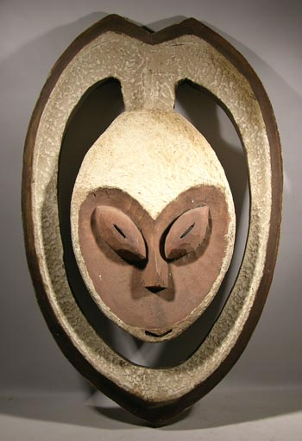  
A fine older Kwele mask from Gabon of western coastal Africa. Lovely form and well carved example with large areas covered with white textured kaolin paint. The white coloring on the mask represents the spirit world - peace and tranquility. This example has pierced eye slots although eyeholes are not always cut through. Kwele mask are not worn on the face during ceremonies and instead are hand-held and shown to the spectators and onlookers. Kwele masks are carved and controlled by the Bwete association, which maintains social order within the tribe. The masks represent the spirits of the forest and are used during initiation ceremonies and or at the end of a mourning period to promote tranquility and well-being within the community. Kwele masks act as intermediaries between the world of the bush and that of the village. The masks are typically heart shaped and have both human-like and animal features with the mouth being very close to the chin. The eyes are narrow with wide arched eyebrows and a small pointed triangular nose. Kwele masks are thought to be among the most beautiful of all African masks.   
  
Condition is near excellent. Minor scrapes and dings along with some staining and cracking of the kaolin paint, consistent with age.   
  
Approx. 18" tall   
  
$375